The high cost of air and water in NH3 refrigeration systems
Air and water in NH3 systems reduces refrigeration capacity and increase power consumption in NH3 refrigeration and heat pump systems.
The “rules of thumb” are:
Air:
Every degree C higher condensing pressure due to air in the system means approx. 3% higher power consumption and approx. 1% less refrigeration capacity.
Water:
Every percent (%) water in the evaporator means approx. 1 % less refrigeration capacity and approx. 2 % higher power consumption.
Further: air (oxygen) and water boost chemical reactions in the system, decompose the oil, create sludge and corrosion increasing service and maintenance cost.
Accurate running cost calculation:
Cool Products has developed a calculation program for accurately calculating the increased running cost with water and air in the system.
The program CPAWcalc. V.1.6 is a free download and can be downloaded from: https://www.dropbox.com/sh/mhn3gl9j7i6efqe/AABOoP9GnQJI8WjHJcT8KCaaa?dl=0

R717 Refrigeration systems:
Example below of a calculation on a R717 one stage -30 °C/+30 °C, 1000 kW system operating with 3% water in the ammonia and 3 °C higher condensing temperature because of air in the condenser.
Capacity and efficiency for the system with and without air and water effecting the system are calculated. In this example the system with air and water will only have 86.36 % system efficiency.

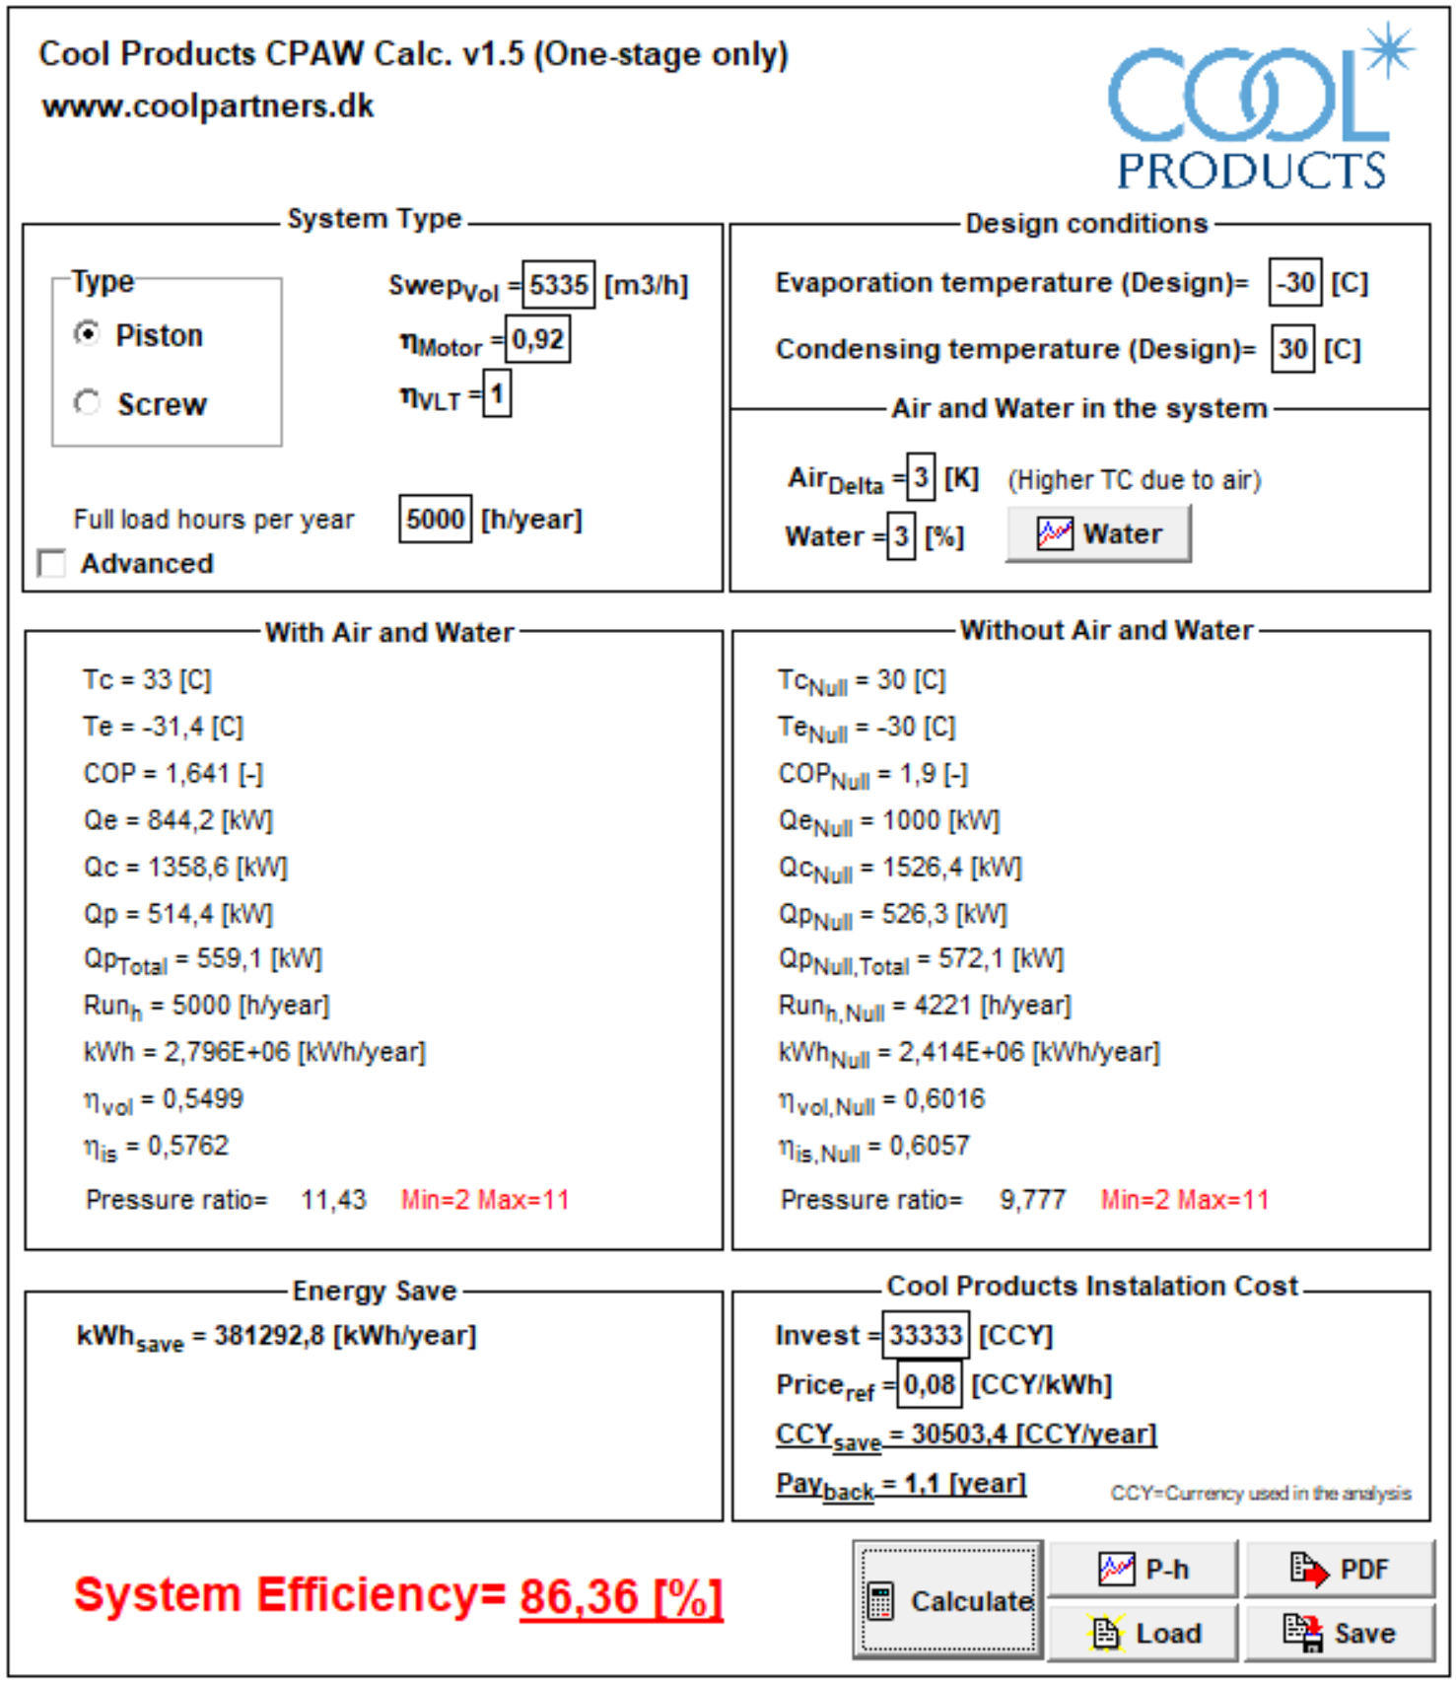
Example of calculation made in the CPAWcalc. Program. The calculation shows the impact of 3 °c higher condensing pressure because of air in the system and 3% water in the R717 where system efficiency is reduced to 86.36 %
If the cost of power, installation of efficient water and air purgers, and running hours is put into the program, a payback time will be calculated as well

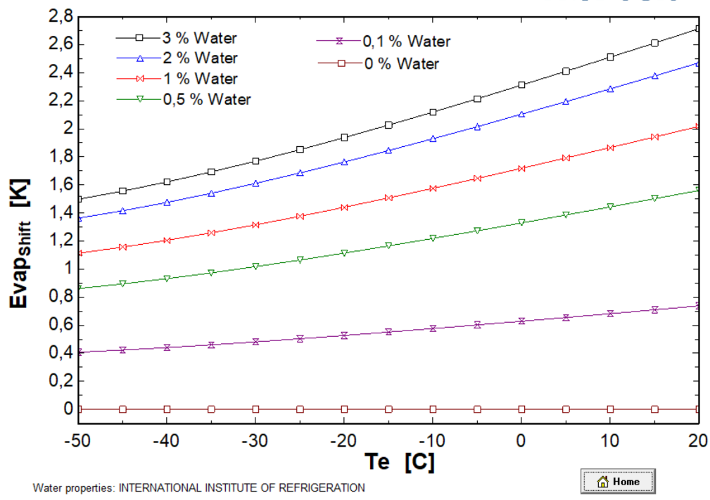
The curves to the left show the changes in evaporating temperatures for R717 the calculations are based on.
These curves can be shown in the program

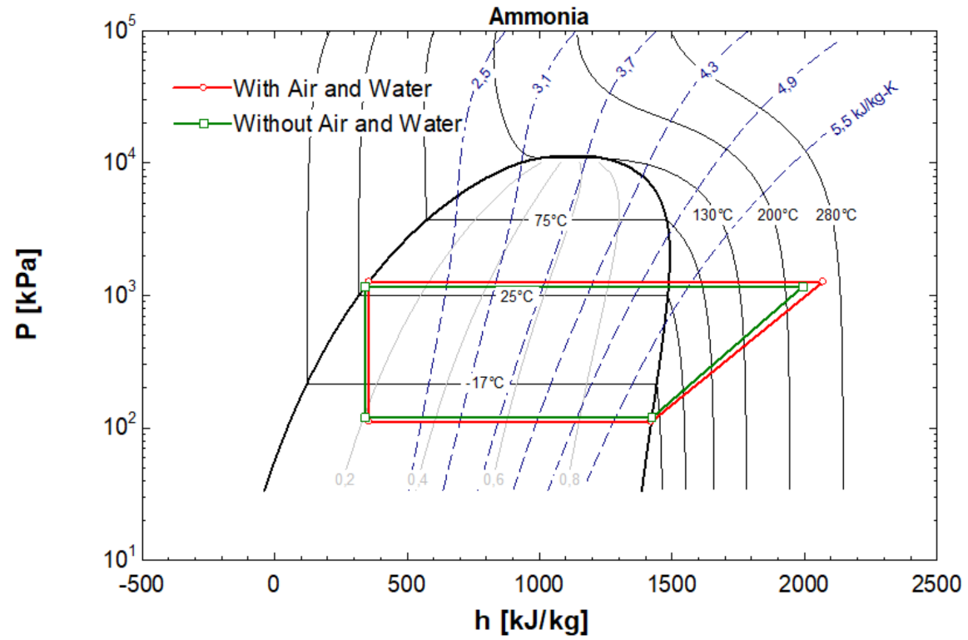

Log Ph diagrams for the calculated systems can be shown in the program.
Green lines with no air and water. Red lines with air and water contamination.

R717 Heat pump systems:
The only reason for selling or buying a R717 heat pump is the COP value (efficiency).
If the COP value of the heat pump drops the economic and financial reasons for investing in a heat pump might not be valid.
COP (hp) of a heat pump is COP (ref) of a refrigeration system plus one:
COP (ref) + 1 = COP (hp)
If an industrial R717 heat pump is delivered with a promised COP (hp) = 4.85 it means you will get 4.85 kW heat for each 1 kW power.
Pure anhydrous NH3 in refrigeration quality has max. 0.3 % H2O
As all H2O ends up in the evaporator you easily get 0.5 % in the evaporator immediately and a little bit of non-condensable (air) gas from chemical reactivity.
Below refrigeration calculations (+20 °C/65 °C) shows the effect of 0.5 % water and 0.5 °C higher condensing temp due to air.
For a heat pump it means COP (hp) = 4.85 drops to COP (hp) = 4.65 when the heat pump is started as brand new.
COP (hp) drop = 4.12 % with new ammonia and 0,5 °C higher CT because of air.
If the heat pump over time reaches 3 % water content and 3 °C higher condensing temp. due to air, we will get COP (hp) = 4.30
COP (hp) drop = 11.34 % with 3 % water and 3 °C higher CT because of air

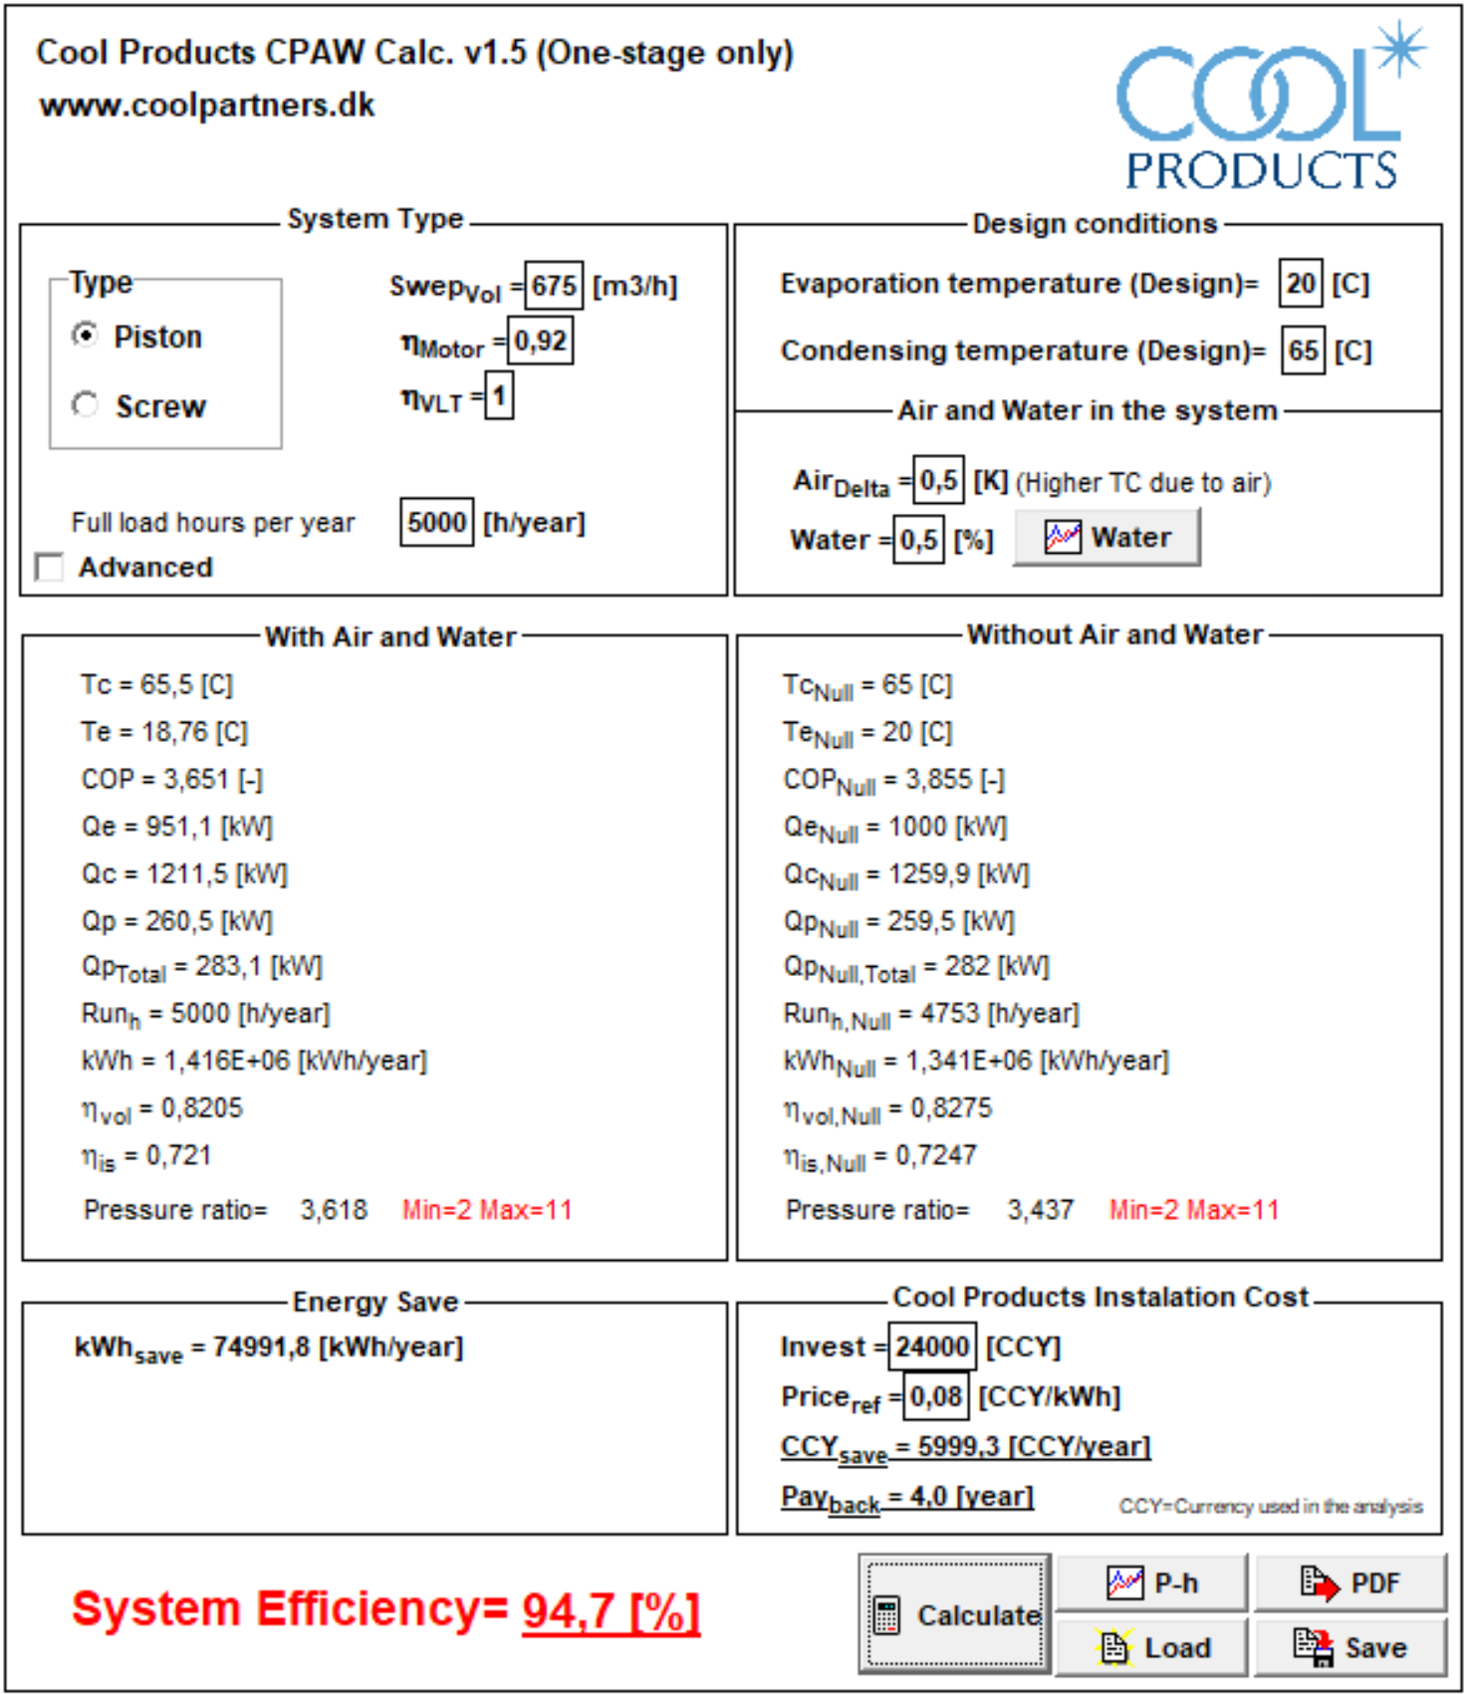

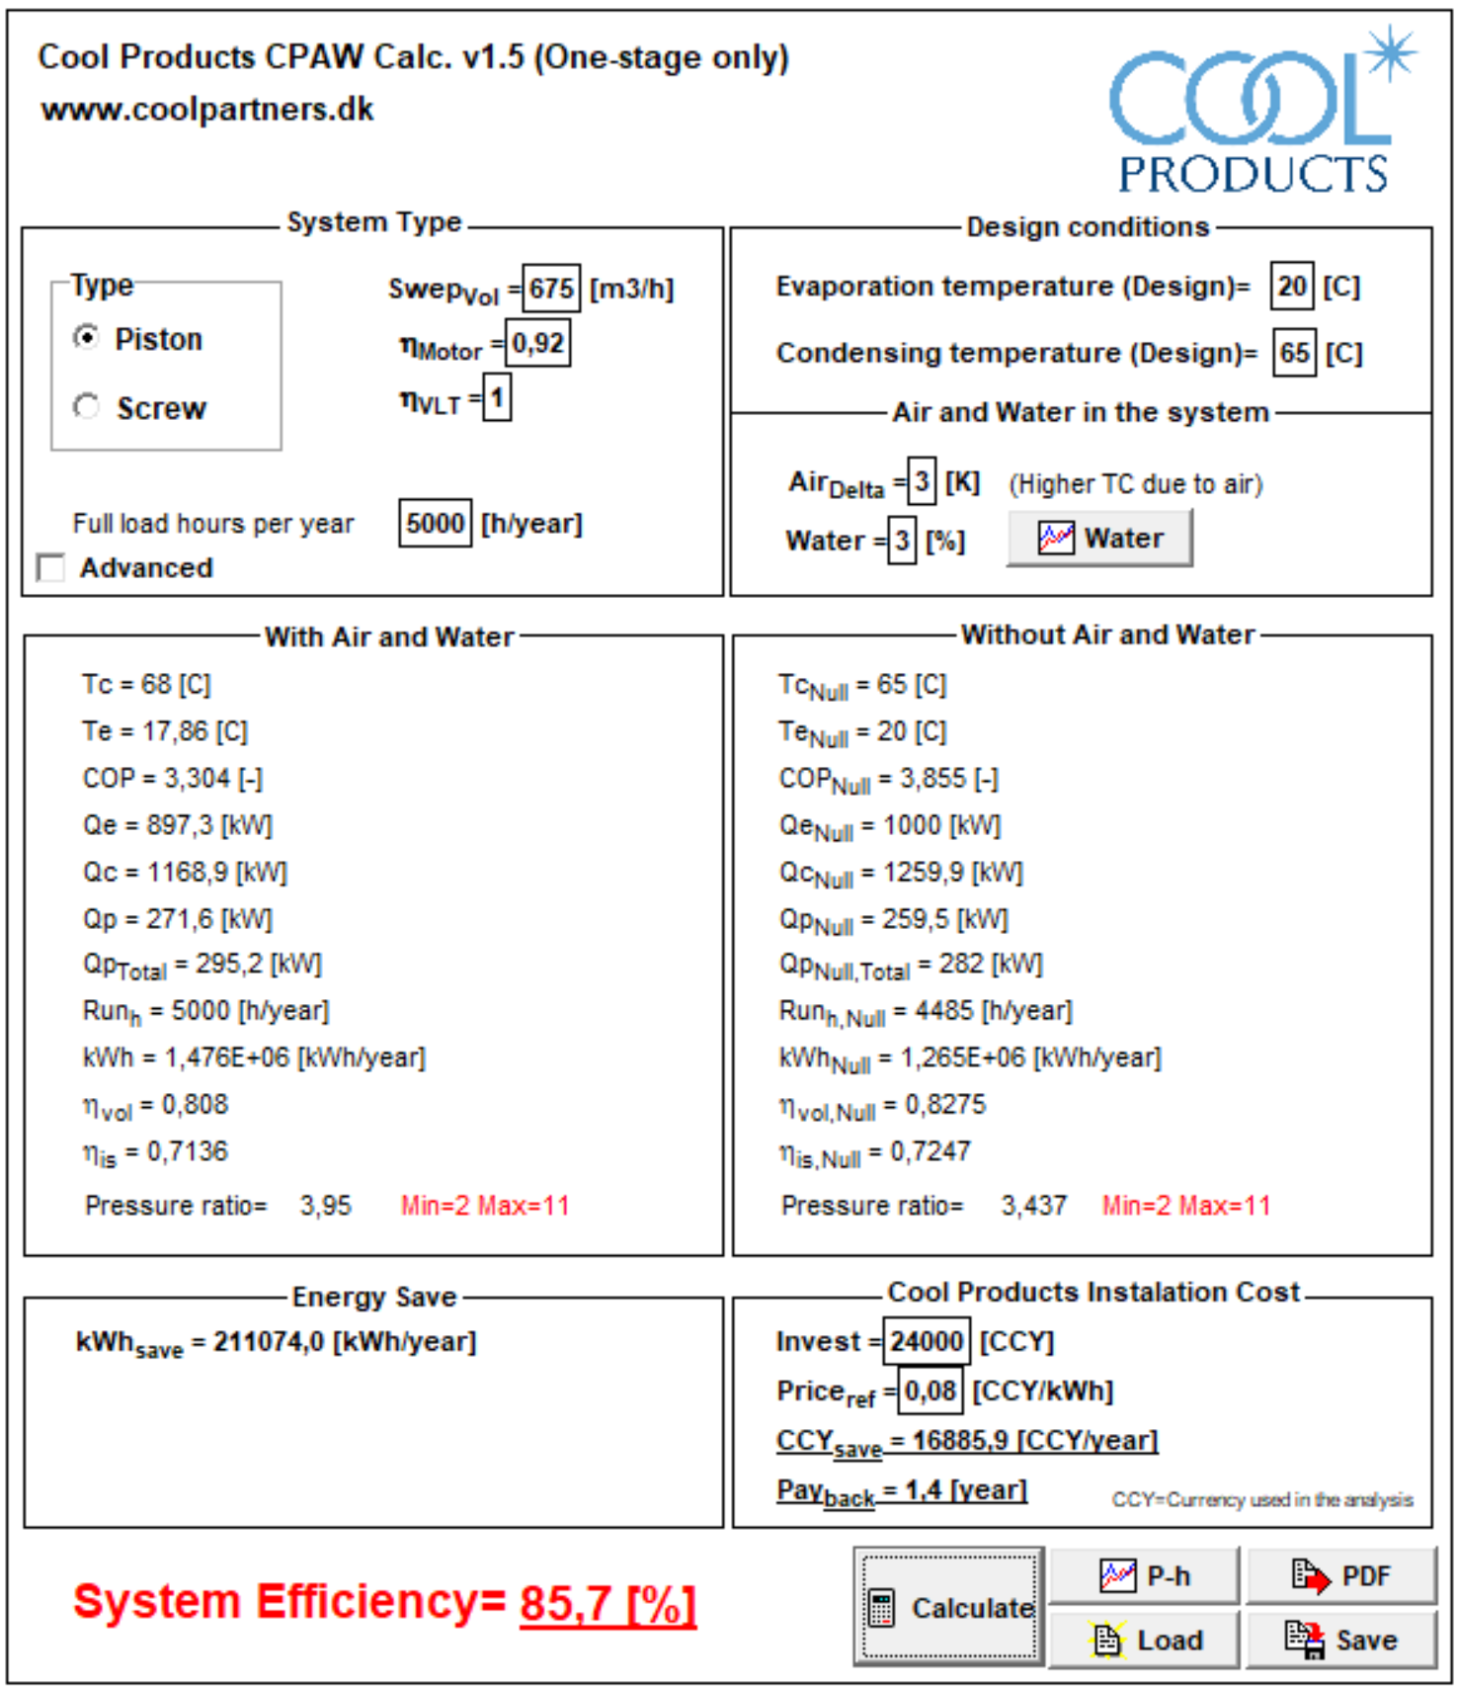

Chemical reactivity:
Air and water contamination also lead to chemical reactivity in R717 refrigeration and heat pump systems. Specially oxygen and water will make the oil decompose and increase service and running cost
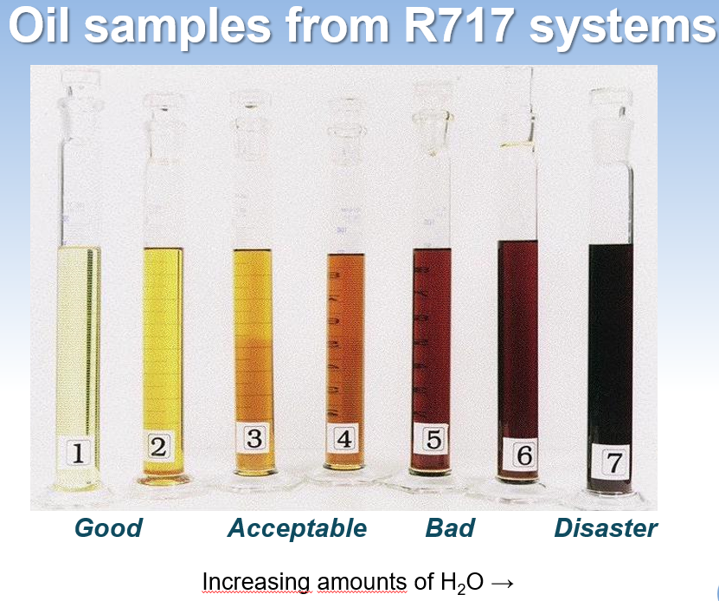

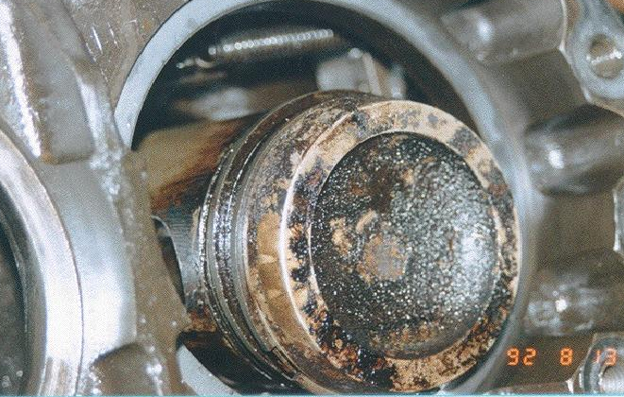
Piston compressor running on air and water contaminated system.

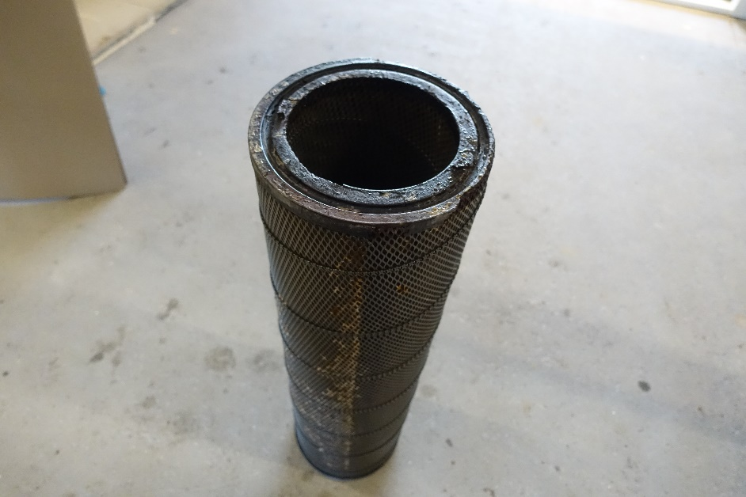
Filter from a heat pump screw compressor oil separator running with air and water and possibly other contamination in a very chemical reactive system.

